VL_8 exercise:

Multiple tables.
SELECT stdFirstName, stdLastName, facFirstName,
facLastName, COUNT(o.offerNo)
FROM Student s INNER JOIN Enrollment e
ON s.stdNo=e.stdNo INNER JOIN Offering o
ON e.offerNo=o.offerNo INNER JOIN Faculty f
ON f.facNo=o.facNo
GROUP BY stdFirstName, stdLastName, facFirstName, facLastName
ORDER BY COUNT(o.offerNo) DESC, stdLastName, stdFirstName,
facLastName, facFirstName

Adveture Work
- SELECT FORMAT( Amount, 'C', 'en-us') as Amount, AccountDescription
FROM FactFinance ff INNER JOIN DimAccount da
ON ff.AccountKey=da.AccountKey
- SELECT DepartmentGroupName, FORMAT(SUM(Amount), 'C',
'en-us')
FROM DimDepartmentGroup dd, FactFinance ff
WHERE dd.DepartmentGroupKey=ff.DepartmentGroupKey
Group by dd.DepartmentGroupName

Frage 1)
1. How does data become information and information
become knowledge?
Data become information because context. Information become knowledge through meaning.
2. What distinguishes Object data from Meta data?
Object data are the data that the user crates. Meta data bringing structure to the database.
3. What happens, if one omits one attribute of a candidate key?
Why?
When you omit an attribute than you lose your key property.

4. Is there always a key candidate in a record? Why?
Yes every record have a key candidate if there is only one than it´s the primary key. If the values of the attributes or the combination in two different records is called the candidate key.
5. Why is it not advisable to index all attributes of a table?
If you change something (edit, delete, insert) it takes longer.
What is the advantage of indexing some?
Search processes are quicker with indexes
6. If a foreign key is defined unique – what kind of relationship
(x:y) does it belong to?
1:1
7. What is the difference between a Key and an Index?
A index is only used to search data faster however the key is used to identify the data and to link tables.
7. Find trivial superkey, superkey and key candidates in the
following table (assuming that the given data reflects all
possible variations):
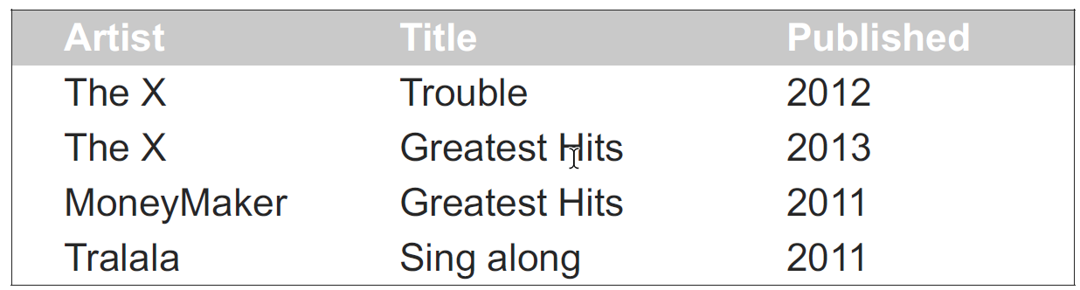
Key candidate ( Artist & Published, Artist & Title, Title& Published)
Superkey (Artist & Published, Artist & Title, Title& Published)
Trivial Superkey (Artist & Title & Published)

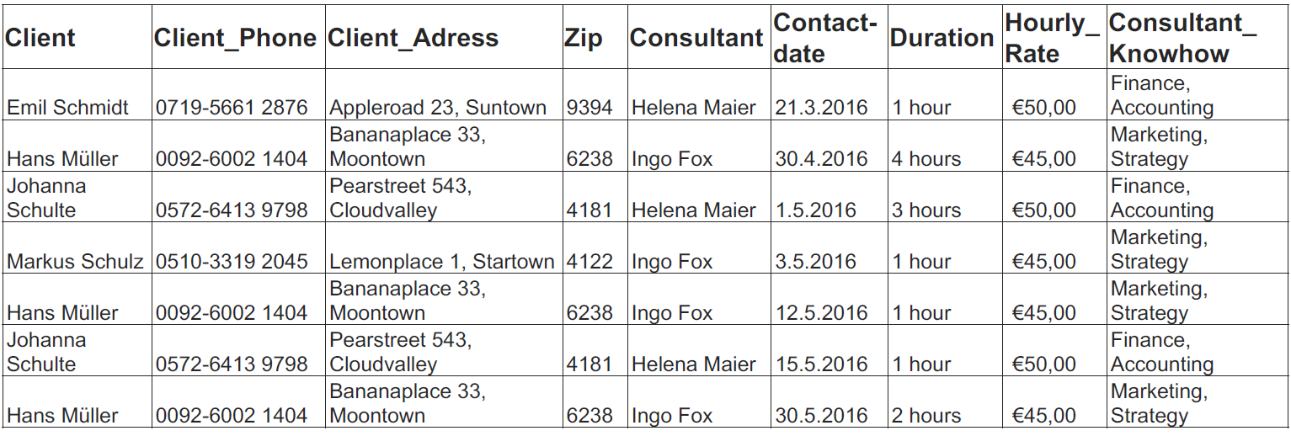
8. How many records are in the table? How many attributes?
Records:7 Attributes:9
9. Which redundancies are in the table?
Hans Müller, Johanna Schulte
Which consequences follow from these redundancies?
Performance loss, waste of storage space and update anomalies.
10. Which entities can you identify in the table?
Client, Consultation, Consultant
Which attributes belong to which entity?
Client: Client, Client_Phone, Client_Adress, Zip
Consultation: Contactdate, Duration
Consultant: Consultant, Hourly_Rate, Consultant_Knowhow

11. How are the entities related to each other?
Client – demands – Consultation – gives – Consultant

Which entity is superordinate to the others?
Client

12. What happens if you delete record 2, 5 and 7?
Hand Müller gets lost

13. What is a n:m relation? How do you build it in a database?
Many tulps point to many tulps. You have to break up the n:m relation to make a 1:n and a 1:m

14. Why are there different data models to describe a planned
(or existing) data base?
Datadesign, system developer and user are different sights on the program.

15. What is an entity?
An object in the real World. The entity can have a physic existence. It is always connected to an object. They also have properties.

16. Explain simple, complex, stored, derived and multi-valued
attributes.
Simple: Has only one value.
Complex: Have values which can be split. (Address)
Stored: Data that is stored as it is.
Derived: Calculated using the stored data (age-birthdate9
Multi-values: May have 0 to may values.

17. The database should be able to store different credit card
numbers (max 3) for one person. Name variants to model this.
1:n

17.b What would change if there where people with joint accounts?

18. Does normalization eliminate all data redundancies? Why?
Normal forms do not eliminate all redundancies. They reduce them as much as feasible .

19. In the formal relational model, a relation is defined as a set
of tuples. Explain what this means. What consequences
does this have, e.g. for the definition of keys?

- A Database to keep track of business trips of employees
- Each employee has an employee-ID, a name (first, last) and belongs to a department.
- For each trip information about start and destination, start- and end-dates is needed and the employee(s) taking part in that trip
- To each location, the name and some more information is stored
- The Travel expenses of a trip are related to an employee and a department that is charged for it
- all expenses (e.g. flight, taxi, restaurant) must be listed separately
Create a conceptual schema using Martin Notation with all needed attributes (that the narrative states), keys and primary keys.
Use natural key where feasible. The solution must follow rules for 3rd normal form.
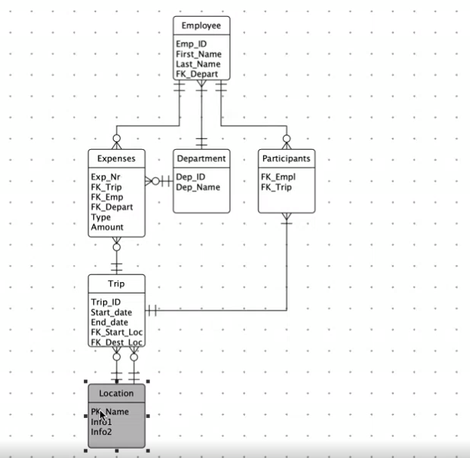
21) Library Martin Notaion
A library has books and borrowers
- Each book comes from a specific publisher and is written by one or
more authors. It is available in the library in one or more copies.
- Each borrower can borrow at maximum 20 books.
- Each book can be borrowed for a specific time. This time can be
extended by 4 weeks twice (if there is no reservation).
Extension
- If all copies of a book are checked out, borrowers can request a
reservation.

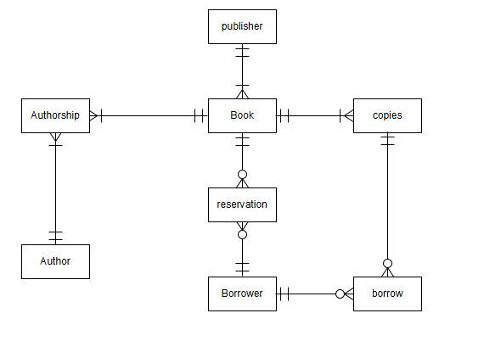
22) A bigger sport happening
- The happening consists of multiple events (each event taking
place at only one complex).
- There are a number of sports complexes where the events can
happen (even at the same time).
- Every complex has multiple areas.
- During an event, there can be multiple competitions (maximal one
at each areas).
- Each sport can take place in only one areas.
- Each sport needs several equipment pieces.
- The equipment can be used by several sports.
- Each piece of equipment is located at one complex and can’t be
moved to other complexes.
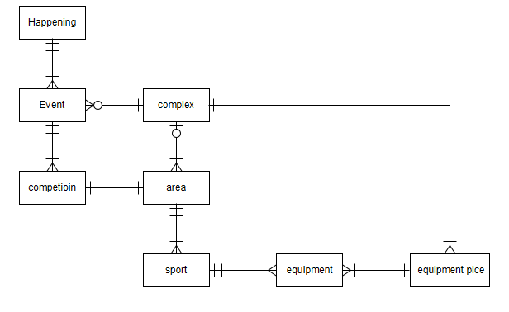
23) AIRLINE relational database – Create the Chen diagram only:
- Each flight is identified by a flight number, and consists of one or
more flight legs with leg numbers 1, 2, 3, and so on.
- Each flight leg has scheduled arrival and departure times,
airports, and one or more leg instances – one for each date on
which the flight travels.
- For each flight leg instance, number of seats and seat
reservations are kept, as is the airplane used on the leg and the
actual arrival and departure times and airports.
- An airplane has an airplane id and is of a particular airplane type.
- Reservations are made for a specific customer and for single legs.
- The different airplane types can only land on specific airports.
These need to be listed in the database.
- An airport is identified by an airport code.
